# 

Summary

History and proposed form/interface

Form/Interface Use Cases

Design Assumptions

Design Decisions

# 

# Summary

This document describes the form/user interface (F/UI) for ordering laboratory tests from iSanté. This F/UI replaces the existing iSanté [HIV] lab form as well as the lab orders section of the primary care and ob-gyn forms. The expected use cases for the form and interface are detailed, assumptions about how the interface will be used are stated, and decisions about how the interface will be constructed are proposed. Stakeholder should understand and agree to these assumptions and decisions prior to our development of the interface.

# Form/Interface Use Cases

1. Order entry
   1. Data clerk: Clinician fills out the paper form by checking off desired lab tests. Data clerk enters the orders to iSanté, potentially with a data entry lag.
   2. POC (point of care): Clinician enters the order items directly into iSanté.
   3. Lab entry: Nothing is entered to iSanté on the order or the patient until patient/sample reaches the lab. At that point the lab must both register the patient and enter the order.
2. Sample transmission to the lab
   1. The paper form (possibly along with a companion locally used lab form) is sent with the patient/sample(s) to the lab.
   2. POC: order number only is provided with the patient/sample sent to the lab.
3. Results entry
   1. Data clerk: a data clerk enters the results
   2. POC: the lab tech enters the results

# History of lab form and lab order interface

## Original Lab Form

The original lab form/interface in iSanté (Appendix A) was used for HIV patients until primary care was added to iSanté, then made available for general use. It allows for both ordering labs and reporting results, in a orders on the left-results on the right format. Since this was prior to the existence of OpenElis, it is presumed that sites use it as follows:

1. Clinician fills out the paper form by checking off desired tests.
2. Clinician or data clerk optionally enters the order items to iSanté.
3. The paper form is attached to a companion locally used lab form and sent with the patient/sample(s) to the lab.
4. The lab performs the order tests and completes the results section.
5. Either the full order including results are entered into iSanté, or, if the order was entered previously, results are added to it.

This form will be replaced by the new forms discussed below for ordering tests and for displaying results per order that are not processed through the external lab. The new form will be capable of

## Primary care/ob-gyn lab order interface

The lab orders section of the primary care/ob-gyn form (Appendix B) is for ordering only and is a much simpler form. It is assumed that a separate locally-used lab form was also filled out to be transported to the lab with the patient/sample(s). It is assumed that OpenElis will send the test results that correspond to these order to iSanté. iSanté does not provide an interface for inputting the results of tests ordered via this form.

This section of the primary care and ob-gyn forms will be replaced by the new lab order form.

# New lab order form and interface

The new form/interface (Appendix C) takes the same approach as the already existing primary care lab orders section, listing all available panels and tests with checkboxes for selection.

* The form is for clinician ordering from iSanté.
* The order will be sent to OpenElis electronically.
* OpenElis will send corresponding results back to iSanté when available.

# Open order form and interface

The open lab order form is the companion interface to the new lab order form. It provides for display of items ordered [only] and allows for viewing and potentially entering of lab results.

# Design Assumptions

# 

# Design Decisions

# 

# 

# Appendix A -- Original iSanté Lab Form

[￼Fiche d'analyses de laboratoire (original PDF version)](https://isante.googlecode.com/files/adult-lab-french0610.pdf)

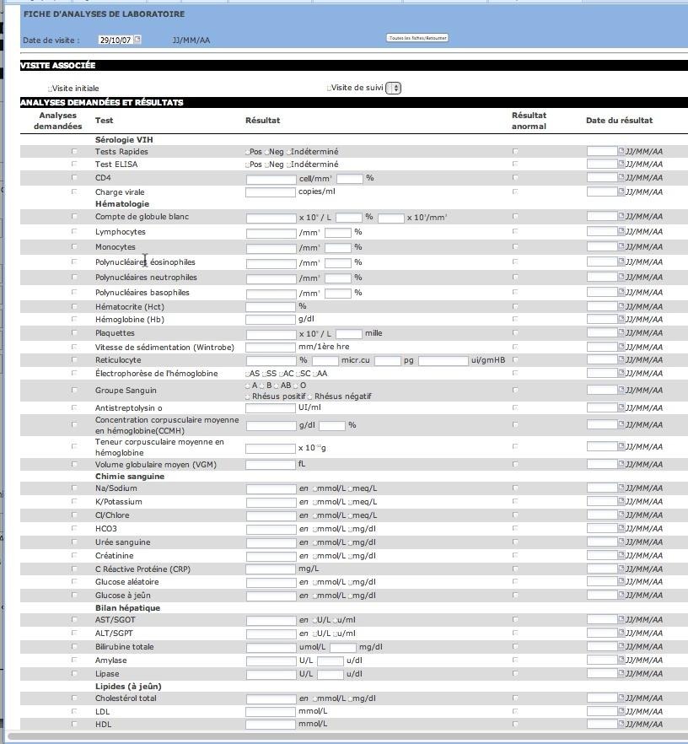

# 

# Appendix B -- iSanté Primary Care Form Lab Order Section

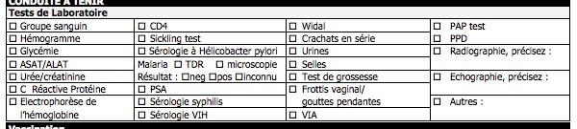

# 

# 

# Appendix C -- Dr. Balan’s proposed Lab Order form

